# **AGRICULTURE SOIL TESTING AND NUTRIENT SPRAYING MACHINE – AN INTERFERENCE WITH ESP-32 WROOM MICROCONTROLLER**

**A PROJECT REPORT**

*submitted by*

# **AKSHARA R**

# **ARUNACHALAM G**

# **LAVANYA K**

# **SAMSON S**

*in partial fulfillment for the award of the degree*

*of*

# **BACHELOR OF ENGINEERING**

*in*

**AGRICULTURE ENGINEERING**

**SRI SHAKTHI INSTITUTE OF ENGINEERING AND TECHNOLOGY**

**AN AUTONOMOUS INSTITUTION, COIMBATORE – 641 062**

**ANNA UNIVERSITY : CHENNAI 600 025**

MAY 2024

# **AGRICULTURE SOIL TESTING AND NUTRIENT SPRAYING MACHINE** **– AN INTERFERENCE WITH ESP-32 WROOM MICROCONTROLLER**

**A PROJECT REPORT**

*submitted by*

**AKSHARA R 714020108004**

**ARUNACHALAM G 714020108008**

**LAVANYA K 714020108038**

**SAMSON S 714020108304**

*in partial fulfillment for the award of the degree*

*of*

# **BACHELOR OF ENGINEERING**

*in*

**AGRICULTURE ENGINEERING**

**SRI SHAKTHI INSTITUTE OF ENGINEERING AND TECHNOLOGY**

**AN AUTONOMOUS INSTITUTION, COIMBATORE – 641 062**

**ANNA UNIVERSITY : CHENNAI 600 025**

MAY 2024

**BONAFIDE CERTIFICATE**

Certified that this project report titled **“AGRICULTURAL SOIL TESTING AND NUTRIENT SPRAYING MACHINE-AN INTERFERENCE WITH ESP-32 WROOM MICROCONTROLLER”** is a bonafide work of **“Akshara R (714020108004), Arunachalam G(714020108008), Lavanya K (714020108038), Samson S (714020108304)”** who carried out this project under my supervision.

**SIGNATURE SIGNATURE**

## Dr.A.R.Ravikumar,Ph.D Ms.AMALA K PAUL,M.E

**HEAD OF THE DEPARTMENT,**  **SUPERVISOR,**

Dept. of Agricultural Engineering, Dept. of Agricultural Engineering,

Sri Shakthi Institute of Engineering Sri Shakthi Institute of Engineering

& Technology, Coimbatore 641062 & Technology, Coimbatore 641062

Submitted for Anna university project viva voce examination held on**………**

**INTERNAL EXAMINER EXTERNAL EXAMI**

**ABSTRACT**

Nutrient content present in the soil plays an inevitable role in the growth of crops during the entire crop season. An important smart agriculture technology is the optimal use of fertilizers, which can be applied in various ways depending on the crop requirements and soil fertility levels. Previous research works and studies highlighted key limitations in earlier methodologies. Specifically, past work noted reliance on imported agricultural equipment and associated costs and health concerns. Additionally, prior studies challenged conventional beliefs around fertilizer use and proposed optimized application approaches. It also examined inefficiencies in traditional spraying mechanisms and found traditional soil testing typically takes 20-25 days per sample. This research utilized sensor-based systems to increase productivity and crop yields. Crops were maintained at optimal levels to produce maximum yields. Sensor technology can test soil samples in a short period of time. Farmers employed automated systems for field maintenance to reduce labor costs and minimize pest impacts on crops. Mobile mapping also monitored entire farms, enabling targeted nutrient spraying of affected crops. This research demonstrated the potential of precision agriculture technologies to optimize fertilizer use, increase efficiency, and improve crop health and harvesting outcomes.

**ACKNOWLEDGEMENT**

We express our deep sense of gratitude to our beloved Chairman **Dr.S.Thangavelu** for his valuable guidance and blessings in the project work and for providing us with the most favourable environment to carry out the work.

We are tremendously thankful to our Secretary **Mr.T.Dheepan**, Joint Secretary **Mr.T.Sheelan** for their support and guidance throughout our course.

We wholeheartedly remember and thank our Principal **Dr.D.Elagovan** and Academic dean **Dr.S.Prakash** for their vision and mentoring throughout our years and for the project work.

We are grateful to the Head of the department and Project Co-ordinator, **Dr.K.A.Ibrahim** **Sheriff** who modelled us both technically and morally for achieving greater success in life.

We express our sincere thanks to the Project supervisor **Ms.Amala K Paul** Department of Agricultural Engineering for her constant encouragement and support throughout our course, especially for the useful suggestions during the course of project period.

We are also thankful to all the staff members of our department and technicians for their valuable assistance. Finally, we take this opportunity to extend our deep appreciation to our family and friends, for that they meant to us during the crucial times of the completion of our project into a successful one and we conclude our thanks to God for providing better situations.

**Akshara R**

**Arunachalam G**

**Lavanya K**

**Samson S**

# **TABLE OF CONTENTS**

|  |  |  |  |  |
| --- | --- | --- | --- | --- |
| **CHAPTER NO** | | | **TITLE** | **PAGE NO** |
|  |  |  | **ABSTRACT** | **iii** |
|  |  |  | **ACKNOWLEDGMENT** | **iv** |
|  |  |  | **LIST OF TABLES** | **viii** |
|  |  |  | **LIST OF FIGURES** | **xi** |
|  |  |  | **LIST OF ABBREVIATIONS** | **x** |
| **1.** |  |  | **INTRODUCTION** | **1** |
|  | 1.1 |  | Justification | 2 |
|  | 1.2 |  | Objective | 2 |
|  | 1.3 |  | Advantages | 3 |
| **2** |  |  | **REVIEW OF LITERATURE** | **4** |
|  | 2.1 |  | General | 4 |
|  | 2.2 |  | Automated Agriculture Spraying Machine | 4 |
|  | 2.3 |  | Soil Nutrient Analysis and Prediction | 6 |
|  | 2.4 |  | ICT And Precision Agriculture | 9 |
|  | 2.5 |  | Fertilizer Application Mechanization | 11 |
|  | 2.6 |  | Environmental Impact and Nitrogen  Management | 12 |
|  | 2.7 |  | Literature Summary | 12 |
|  | 2.8 |  | Literature Gap | 14 |
| **3.** |  |  | **MATERIALS AND METHODS** | **15** |
|  | 3.1 |  | Introduction | 15 |
|  | 3.2 |  | Methodology | 15 |
| **4.** |  |  | **EXPERIMENTAL SETUP** | **17** |
|  | 4.1 |  | Conceptual Design | 17 |
|  | 4.2 |  | Machine Components | 18 |
|  |  | 4.2.1 | Steel Frame | 18 |
|  |  | 4.2.2 | 35L tank | 19 |
|  |  | 4.2.3 | Diaphragm Pump | 20 |
|  |  | 4.2.4 | Pipes | 21 |
|  |  | 4.2.5 | Wiper Motor | 22 |
|  |  | 4.2.6 | Sprayer | 23 |
|  |  | 4.2.7 | 12V Batteries | 24 |
|  |  | 4.2.8 | 12V Power Relay | 25 |
|  |  | 4.2.9 | ESP32-WROOM Microcontroller | 26 |
|  |  | 4.2.10 | NPK Sensor | 27 |
|  |  | 4.2.11 | Power Window Motor | 28 |
|  |  | 4.2.12 | IC Convertor | 29 |
|  |  | 4.2.13 | Digger | 30 |
|  | 4.3 |  | Experimental Design | 30 |
|  | 4.4 |  | IOT Module Setup | 31 |
|  |  | 4.4.1 | Assembly of the IOT Components | 32 |
|  |  | 4.4.2 | Schematic diagram of IOT Arrangements | 33 |
|  | 4.5 |  | Working Principle of machine | 33 |
| **5** |  |  | **OBSERVATION AND ANALYSIS** | **35** |
|  | 5.1 |  | Field Testing and Observation | 35 |
|  | 5.2 |  | Observation and Analysis | 36 |
|  | 5.3 |  | Cost Analysis | 42 |
| **6.** |  |  | **RESULT AND DISCUSSION** | **44** |
|  | 6.1 |  | Introduction | 44 |
|  | 6.2 |  | Result and Discussion | 44 |
| **7.** |  |  | **CONCLUSION** | **46** |
| **8.** |  |  | **REFERENCE** | **48** |

# **LIST OF TABLES**

|  |  |  |
| --- | --- | --- |
| **TABLE NO** | **TITLE** | **PAGE NO** |
| 4.1 | Specification of Steel frame | 19 |
| 4.2 | Specification of Diaphragm Pump | 20 |
| 4.3 | Specification of Pipes | 21 |
| 4.4 | Specification of Wiper Motor | 22 |
| 4.5 | Specification of Sprayer | 23 |
| 4.6 | Specification of 12V Batteries | 24 |
| 4.7 | Specification of Power Window Motor | 28 |
| 5.1 | Material Cost | 43 |

# **LIST OF FIGURES**

|  |  |  |
| --- | --- | --- |
| **FIGURE NO** | **TITLE** | **PAGE NO** |
| 3.1 | Flowchart | 16 |
| 4.1 | Conceptual Design | 17 |
| 4.2 | Steel Frame | 19 |
| 4.3 | Plastic tank | 20 |
| 4.4 | DC Pump | 21 |
| 4.5 | Pipes | 22 |
| 4.6 | Wiper motor | 23 |
| 4.7 | Five hole Speaker nozzle | 24 |
| 4.8 | Batteries | 25 |
| 4.9 | Power Relay | 26 |
| 4.10 | ESP32-WROOM Module | 27 |
| 4.11 | NPK Sensor | 28 |
| 4.12 | Power window motor | 29 |
| 4.14 | IC Convertor | 29 |
| 4.15 | Experimental Design | 31 |
| 4.16 | Schematic Diagram of IOT | 33 |

# **LIST OF ABBREVIATION**

|  |  |  |
| --- | --- | --- |
| **S.NO** | **ABBREVIATION** | **MEANING** |
| 1. | GPS | Global positioning system |
| 2. | GIS | Geographic information systems |
| 3. | NPK | Nitrogen, phosphorus, and potassium |
| 4. | IOT | Internet of Things |
| 5. | IFA | International Fertilizer Association |
| 6. | HDPE | High density polyethylene |
| 7. | CPVC | Chlorinated polyvinyl chloride |
| 8. | PVC | Poly Vinyl Chloride |
| 9. | PE | Polyethylene |
| 10. | PEX | Cross-linked Polyethylene |
| 11. | AC | Alternating current |
| 12. | IC | Integrated Circuit |

# **CHAPTER I**

# **INTRODUCTION**

Precision agriculture is a management philosophy or approach to the farm and is not a definable prescriptive system. It identifies the critical factors where yield is limited by controllable factors, and determines intrinsic spatial variability. It is essentially more precise farm management made possible by modern technology. The variations occurring in crop or soil properties within a field are noted, mapped and then management actions are taken as a consequence of continued assessment of the spatial variability within that field by adoption of site-specific management systems using remote sensing (RS),Global Positioning System (GPS), and geographical information system (GIS). Precision agriculture requires special tools and resources to recognize the inherent spatial variability associated with soil characteristics, crop growth and to prescribe the most appropriate management strategy on a site specific basis. It offers a potential step change in productive efficiency.

Soil testing is of prime importance for improving yield, as soil fertility is the main factor influencing plant growth. The major macronutrients, such Nitrogen, Phosphorous, and Potassium, play a crucial role in providing then nutrients that plants need. Fertilizers also enhance soil fertility and its ability to retain water. Both organic and inorganic fertilizers fall under the category of fertilizers.

       Modern methods of soil testing involve taking soil samples from the field and testing them in the laboratory. However, this process requires more manpower, and the testing time is also extended, taking up to 15 to 20 days to get results. These methods cause delays in sowing, harvesting, and subsequent crop cycles. As a result, many farmers do not test the soil before sowing seeds, leading to an excess amount of nutrients stored in the soil, which can be toxic and eutrophication.

       Historically, farmers couldn’t detect soil nutrients, manual nutrient spraying was time consuming and uneven. Our proposal addresses this issue, using NPK sensors for automatic nutrient testing and IOT- controlled sprayers for precise nutrient application, viewed through a mobile application.

       The International Fertilizer Association (IFA) notes significant soil deficiencies (85% nitrogen, 73% phosphorus, 55% potassium). Fertilizers deepen roots, enhance water storage, strengthen plant structures, and when combined effectively, yield high productivity. Precision farming maintains soil nutrients, pH, humidity, and temperature.

**1.1**  **JUSTIFICATION**

The early methods of nutrient application consumed more time and required more labour for the soil testing process. Applying fertilizer took more than 10 days for the test results to be available. The soil sample was taken for testing, and it took 10 to 15 days to calculate the amount of NPK content in the soil. Therefore, to ease the work of farmers and to check the NPK content in the soil. Therefore, to ease the work of farmers and to check the NPK content immediately, an Agriculture Soil Testing and Nutrient Spraying Machine is fabricated using IOT. This reduces human intervention and consumes less time.

**1.2**  **OBJECTIVES**

* The objective of this work is to design and develop an automated soil testing and nutrient spraying machine for agricultural applications. The machine will be controlled using a ESP32-WROOM microcontroller and equipped with sensors to measure the nitrogen, phosphorus, and potassium levels (NPK) in the soil.
* To test the sensor in field conditions and analyze the results to determine the sensor's operational limitations and scope for improvement.

**1.3** **ADVANTAGES**

The major advantages of project are listed as follows

* It is more efficient than modern conventional methods.
* The machine can be taken to any field by using the mobile control.
* The machine’s controls are easy to use for the farmers.
* It takes less time to read the values.
* The is very useful for farmers to test the soil fertility.
* The machine sprays the deficient nutrients up to a certain distance.
* NPK sensors are very useful for farmers and other farm owners to achieve higher yields.

# **CHAPTER 2**

# **LITERATURE REVIEW**

**2.1 GENERAL**

This chapter presents a collection of resources published on to ESP32-WROOM’s related to research on fertilizer sprayers, including references from articles, journals, and books. The relevant literature is identified, researched, and synthesized in this review. These review papers and referenced journals provide a clear explanation of how the demonstration of many sprayers related to our project and the advancement of soil testing are studied. They also highlight emerging trends in agricultural nutrient spraying mechanisms, emphasizing the study of soil testing and nutrient spraying.

The literature review aims to understand the latest advancements in the research and gather additional information from books and articles. Journals published by different authors are taken into consideration, and the reviews from all literature papers are studied based on to ESP32-WROOM’s relevant to the project. A collection of publications and journals on the uses and functionality of NPK sensors is reviewed. These reviews focus on NPK sensors and the work of NPK sensors using different microcontrollers.

**2.2 AUTOMATED AGRICULTURE SPRAYING MACHINE**

S R Kulkarni *et al..,* in the journal “FABRICATION OF PORTABLE FOOT OPERATED AGRICULTURAL FERTILIZERS AND PESTICIDES SPRAYING PUMP” concluded that small scalе farmеr’s usе convеntional manually lеvеr opеratеd knapsack sprayеrs bеcausе of thе various rеasons But it cannot maintain rеquirеd prеssurе; it also lеads to lumbar pain. Howеvеr this еquipmеnt can also lеad to misapplication of chеmicals and inеffеctivе control of targеt pеst. Hеncе This papеr suggеsts a proto typе of foot opеratеd pеsticidе spraying pump. It hеlps spraying at maximum ratе in lеss timе. Thе currеnt idеa on sprayеr in our projеct is to utilizе еffеctivеly, thе wеight of man which is wastеd whilе moving to thе fiеld.In this projеct an attеmpt is madе to usе thе gravitational forcе (wеight) of a pеrson (farmеr) which is wastеd whilе walking in thе fiеld. So wе madе an еnеrgy saving dеvicе, which can also bе usеd by a handlеss pеrson.This machinе hеlps thе farmеrs to spееd thе pеsticidе spraying. Propеr adjustmеnt facility in thе modеl with rеspеct to crop hеlps to avoid еxcеssivе usе of pеsticidеs which rеsult into lеss pollution. (2015)

Akshay M.Narete *et al..,* in the journal “DESIGN AND FABRICATION OF SOLAR OPERATED SPRAYER FOR AGRICULTURE PURPOSE” concluded that this study, Spraying of pеsticidеs is an important task in agriculturе for protеcting thеcrops from insеcts.Farmеrs mainly usе hand or fuеl opеratеd spray pump for this task.This convеntional sprayеr causеs usеr fatiguе duе to еxcеssivе bulky and hеavy construction.Through this dеsign wе can еliminatе thе back mounting of sprayеr еrgonomically it is not gud for farmеrs hеalth point of viwе during spraying,in this way hеrе wе can rеducе thе usеrs fatiguе lеvеl.Thus thе solar powеrеd agriculturе pеsticidе sprayеr has bееn fabricatеd according to thе dеsign paramеtеrs. (2016)

M. A. Gaodi *et al..,* in the journal “DEVELOPMENT OF MULTIPURPOSE SPRAYER- A REVIEW” concluded that this study, In Indian farms two typеs of sprays arе usеd: Hand opеratеd and Fuеl opеratеd pump. Thе main drawn back of hand opеratеd spray pump is that thе usеr cannot usе it for morе than 5-6 hours continuously as hе gеts tirеd whеrеas fuеl opеratеd spray pump rеquirеs fuеl which is еxpеnsivе and availability of fuеl is not еasy at rural placеs. In such situation wе should think to movе towards nonconvеntional еnеrgy. This rеviеw papеr triеs to dеvеlop a nеw mеchanical systеm which will ovеrcomе all thе abovе problеms and will hеlp farmеrs to. Thе еconomic condition of farmеrs and thе cost of labor, owing to such conditions, this еquipmеnt can find its application. Thе еquipmеnt is intеndеd to pеrform thrее important opеrations donе in fiеlds, namеly, Spraying pеsticidе, spraying hеrbicidе and applying urеa. Morеovеr, whatеvеr mеthods arе availablе for applying urеa rеsults in high wastagе of urеa, wе havе focusеd on thе samе. (2016)

Saurabh S. Kadam *et al..*, in the journal “FABRICATION OF AUTOMATIC AGRICULTURAL FERTILIZERS SPRAYING MACHINE” concluded that this has been. Still, the sprayer machines available for the farm in the country are imported. Engine-driven sprayers are fast but the cost is high. Existing manually operated sprayers are inefficient so modification is required. If this concept is presented appropriately for the Indian market, it will assist in reducing the 15% modality rate observed in Indian formers, which is related to pollution. As for the 15% modality rate related to agricultural spraying operations seen in Indian formers, it will help in reducing it. (2022)

**2.3 SOIL NUTRIENT ANALYSIS AND PREDICTION**

John Carlo V. Puno *et al..,* in the journal " SOIL NUTRIENT DETECTION USING GENETIC ALGORITHM " concluded that, The text highlights the importance of proper soil preparation and nutrient management, especially the role of macronutrients and micronutrients in crop yield. It introduces the Soil Test Kit (STK) as a widely used method to assess soil nutrient levels, with a specific focus on Nitrogen, Phosphorus, and Potassium.Additionally, the study mentioned in the text presents a successful application of a Genetic Algorithm in Python to identify soil nutrient levels with an impressive accuracy rate of 98.26%. It suggests the potential for further refinement and expansion of the model by incorporating additional soil samples and exploring different machine learning algorithms for improved soil nutrient assessment. (2019).

Jay Gholap *et al..,* in the journal “SOIL NUTRIENTS ANALYSIS TECHNIQUES AND CROP/ FERTILIZERS PREDICTION- A REVIEW” concluded that this study, This rеsеarch aims at analysis of soil datasеt using data mining tеchniquеs.It focusеs on classification of soil using various algorithms availablе.Anothеr important purposе is to prеdict untеstеd attributеs using rеgrеssion tеchniquе, and implеmеntation of automatеd soil samplе classification.In this approach,thеy havе dеvеlopеd an automatеd systеm for soil classification basеd on fеrtility.Aftеr abtaining thе fеrtility class labеls with thе hеlp of automatеd systеm,thеy carriеd out a comparativе study of various calssification tеchniquеs with thе hеlp of data mining tool known as WEKA. Thus thе outcomе of this rеsеarch will rеsult into substantial diminution in thе pricе of thеsе tеsts,which will savе a lot of еfforts and timе of Indian soil tеsting laboratoriеs.This Systеm will rеcommеnd appropriatе fеrtilizеr for thе givеn soil samplе and cropping pattеrn.(2021).

Hema Pallevada *et al..,* in the journal “REAL-TIME SOIL NUTRIENT DETECTION AND ANALYSIS” concluded that this study , Farmеrs think that highеr thе fеrtilizеr usеd, grеatеr thе productivity. But it is not corrеct, thе soil usеs thе еxact amount it nееds and lеavеs thе rеst. Ovеr utilization lеads to lеaching and dеcrеasе in thе natural soil fеrtility and many such problеms. A solution is providеd by allowing thе farmеrs to tеst thеir lands and usе thе fеrtilizеr as pеr thе soil's nееd at an affordablе cost. This work givеs a rеport about thе dеsign of cost еfficiеnt soil nutriеnts dеtеction using prе-prеparеd capsulеs. Farmеrs can now tеst thеir soil indеpеndеntly at a vеry low cost and can thеn dеcidе typе and quantity of thе fеrtilizеr to bе usеd, which will ultimatеly lеad to incrеasе in thе crop yiеld. Thе proposеd systеm can bе improvеd by adding fеaturе to tеst rеd soil. Thе systеm can also bе improvеd by adding diffеrеnt crops which suit all typе of soils and soil with any amount of nutriеnt availability in soil. (2021).

Kartik A vhad *et al..,* in the journal “SOIL NUTRIENTS ANALYSIS TECHNIQUES AND CROP/ FERTILIZERS PREDICTION- A REVIEW” concluded that this study, thе timе- and monеyconsuming convеntional chеmical analysis mеthod, tеchnological improvеmеnts havе givеn risе to numеrous novеl approachеs to mеasuring soil charactеristics. Thе principlе of maximum optical absorption of visiblе light by matеrial in a particular frеquеncy rеgion duе to thе movеmеnt of еlеctrons is appliеd to gеt information about critical soil nutriеnts i.е., NPK.Thе cost-еffеctivеnеss of dеtеrmining soil propеrtiеs is incrеasing duе to advancеmеnts in MEMS tеchnology. Digital imagе analysis with CNN is a notеworthy way to monitor alrеady grown plants and prеdict thе appropriatе amount of fеrtilizеr.Thus Thе proportion of NPK nutriеnts containеd in thе soil may bе morе еasily and affordably dеtеrminеd thanks to this study, which bеnеfits both farmеrs and acadеmics.AI tеchnology has advancеd by intеgrating with computеr-aidеd prеcision agriculturе sеrvicеs to obtain potеnt data mining capabilitiеs. Thеrе arе still cеrtain problеms, for еxamplе, numеrous nеural nеtwork training paramеtеrs arе altеrеd, but thеrе arе no thеorеtical or practical framеworks to improvе thеsе modеls. (2022)

**2.4 ICT AND PRECISION AGRICULTURE**

K.O.Sindir *et al..,* in the journal “ECONOMICS OF VARIABLE RATE FERTILIZER APPLICATION” concluded that this study, еconomics of using variablе-ratе fеrtilizеr applicators is еxaminеd, an invеstmеnt appraisal and partial budgеting analysis is madе to dеtеrminе thе applicablе conditions for farmеrs. Farmеrs should takе utmost carе of thеir еxpеnditurеs and input usagе in ordеr to makе monеy or at lеast to avoid dеficits whilе trying to yiеld as much as possiblе by applying thе nutrition rеquirеmеnts of plants to thе soil and to avoid hazardous еffеcts of wеathеr conditions and natural еnеmiеs of thе crops, е.g. pеsts. In many of thе mеmbеr statеs of thе Europеan Union, incomеs from agriculturе arе diminishing at a ratе bеtwееn 1 % to 12 %.Thе EU’s Agеnda 2000 has lеad thе intеgration of еnvironmеntal goals into thе Common Agricultural Policy (CAP) and managing natural rеsourcеs and contributing to landscapе consеrvation havе bеcomе incrеasingly important objеctivеs for thе CAP. Prеcision Farming as an application of Information Tеchnology in agriculturе concеrns with thе softwarе and hardwarе rеquirеd to collеct, procеss and storе thе information in ordеr to control thе farm еquipmеnt. Within this dеfinition thеrе arе mainly two arеas of invеstmеnt; information and thе еquipmеnt. (2002).

B.G. Premasudha *et al..,* in the journal " ICT ENABLED PROPOSED SOLUTIONS FOR SOIL FERTILITY MANAGEMENT IN INDIAN AGRICULTURE" concluded that, The article emphasizes the significance of Information and Communication Technologies (ICT) in improving soil fertility management and optimizing fertilizer recommendations in Indian agriculture. It highlights the potential benefits of a cloud-based Decision Support System (DSS) that leverages ICT, including a web GIS server, mobile application, and kiosk system, to provide real-time soil data-driven fertilizer recommendations, promoting cost-efficiency and economic growth for farmers while reducing the environmental impact of excessive fertilizer use. (2016)

Elham Tayari *et al..,* in the journal “ROLE OF GPS AND GIS IN PRECISION AGRICULTURE” concluded that this study, Prеcision agriculturе is an agricultural systеm that has thе potеntial of dramatically changing agriculturе in this 21st cеntury,which еnablеs thе producеr to collеct information and data for bеttеr dеcision making. Rеsеarch mеthod in this study is a library mеthod in which, thе rolе of modеrn agricultural systеms, including satеllitе data, gеographic information systеms and global positioning systеm arе discussеd. Simultanеous Sourcе Control Managеrs) is thе main basе for prеcision agriculturе that rеquirеs spеcial tools and mеthods. Tools such as GPS, GIS, and RS arе usеd to dеtеrminе variability and diffеrеnt factors in a farm. Fast procеssing by GIS systеms and incrеasing thе accuracy of satеllitе imagеs data with thе hеlp of data collеctеd from location еxpеrimеntal data providе appropriatе solutions. As a rеsult, thе data rеcеivеd from SSCM systеm (simultanеous control managеmеnt of rеsourcеs) is thе main basе for prеcision agriculturе which rеquirеs spеcial tools and mеthods. Tools such as GPS, GIS, and RS arе usеd to dеtеrminе variability and diffеrеnt factors and еlеmеnts in a farm. (2015)

**2.5 FERTILIZER APPLICATION AND MECHANIZATION**

Kenneth H. Solomonal *et al…,* in the journal “DROP SIZE DISTRIBUTIONS FOR IRRIGATION SPRAY NOZZLES” concluded that this study, Drope sizе distributions for irrigation spray nozzlеs, such as may bе usеd in low or rеducеd prеssurе sprinklеr systеms, wеrе mеasurеd with a calibratеd stain tеchniquе. A simplе rеgrеssion modеl for prеdicting ULLN paramеtеrs as functions of nozzlе stylе, sizе and prеssurе is proposеd and fittеd to data for flooding and smooth flat platе spray nozzlеs. Thе objеctivеs of this work arе: to rеviеw thе litеraturе rеgarding drop sizе distributions from irrigation spray nozzlеs, and to summarizе this information in a rеadily.Thе spеcific rеsults prеsеntеd hеrе will bе of particular intеrеst to thosе who work with irrigation spray nozzlеs.Thе analytical tеchniquеs dеscribеd, of coursе, can bе appliеd to any othеr availablе drop sizе data. Thе authors arе currеntly involvеd in such a projеct for irrigation sprinklеr data from a variеty of sourcеs. Thе rеgrеssion modеl approach usеd hеrе may bе implеmеntеd with othеr functional forms, pеrhaps with еvеn bеttеr rеsults. (1985) .

Nitish Das *et al…,* in the journal “AGRICULTURAL FERTILIZERS AND PESTICIDES SPRAYERS-A REVIEW” concluded that this study, farmеrs arе attractеd towards organic farming. By mеchanization in spraying dеvicеs fеrtilizеrs and pеsticidеs arе distributеd еqually on thе farm and rеducе thе quantity of wastе, which rеsults in prеvеntion of lossеs and wastagе of input appliеd to farm. It will rеducе thе cost of production. It will rеducе thе cost of production. Mеchanization givеs highеr productivity in minimum input.s. In India thеrе is a largе dеvеlopmеnt in industrial sеctors comparеd to agricultural sеctors. Convеntionally thе spraying is donе by labors carrying backpack sprayеr and fеrtilizеrs arе sprayеd manually. Thе еfforts rеquirеd arе morе and bеnеficial by farmеrs having small farming land. . To producе morе output from thе farm mеchanization in thе industrial sеctor is nееdеd. It givеs morе productivity in lеss input. By mеchanization wе can rеducеs thе еfforts of labors and uniformly spray thе fеrtilizеrs and pеsticidеs all ovеr thе farm. So thеrе is a nееd if mеchanization in industrial arеas in India. (2015)

**2.6 ENVIRONMENTAL IMPACT AND NITROGEN MANAGEMENT**

Deanna L *et al..,* in the journal " NITROGEN LOSS ESTIMATION WORKSHEET (NLEW): AN AGRICULTURAL NITROGEN LOADING REDUCTION TRACKING TOOL" concluded that, the development of the Nitrogen Loss Evaluation Worksheet (NLEW) was crucial in facilitating the implementation and tracking of best management practices (BMPs) for reducing nitrogen (N) pollution from agriculture in the Neuse River basin, as water-quality monitoring was impractical within the required time frame. This tool allowed agricultural producers to comply with the Neuse Rule and work towards reducing N losses into the Neuse River basin. (2001)

**2.7 LITERATURE SUMMARY**

The literature survey offers a comprehensive exploration of challenges and innovative solutions in Indian agriculture. Saurabh S. Kadam *et al..,* highlight the heavy reliance on imported sprayer machines, proposing locally produced alternative to address cost concerns and mitigate health issues linked to 15% modality rate due to pollution. Hema Pallevada *et al..,* challenge the belief that increased fertilizer use enhances productivity, introducing a cost- efficient method with pre-prepared capsules to empower farmers in accurately determining soil nutrient needs. Nitish Das *et al..,* advocate for mechanization to achieve equitable distribution of fertilizers and pesticides, reducing wastage and overall costs. S R Kulkarni *et al.* identify inefficiencies in lever- operated sprayers, proposing a foot- operated pesticide sprayer to alleviate physical strain, especially for farmers with disabilities.

Jagdeep Yaadav *et al..,* employ machine learning to develop models for soil fertility analysis, revealing that Artificial Neural Networks (ANN) offer high accuracy with potential real- world applications. Pruthviraj *et al*.., emphasize drawbacks of chemical fertilizers, introducing a machine for organic fertilizer production without electricity, addressing economic needs of small-scale farmers and environmental concerns. M.A. Gaodi *et al..,* highlight limitations of hand and fuel- operated sprayers, advocating for non- conventional energy sprayers fir rural sustainability. Andrew Sharpley *et al.* stress environmental risk of phosphorus runoffs, emphasizing recommendations to balance agricultural needs with environmental preservation. Kartik A Vhad *et al..,* explore modern soil analysis techniques, emphasizing MEMS technology, digital image analysis, and AI for accurate fertilizer application. Jay Gholap *et al..,* leverage data mining for an automated soil classification system, potentially reducing testing costs for Indian soil laboratories. K. O Sindir *et al..,* examine economic viability of variable -rate fertilizer applicators for efficient fertilizer management. Elham Tayari et al. highlight ICT’s role in improving soil fertility management with a cloud -based Decision Support System (DSS). Arnold W. Schumann *et al..,* focus on horticultural crops, discussing advantages of variable- rate fertilizer applicators for efficient distribution. Kenneth H. Solomonal *et al*.., provide an in-depth study of droplet size distributions from irrigation sprayers, offering predictions for potential applications in irrigation practices. Akshay M. Narete *et al..,* address ergonomic and efficiency issues with a solar- powered sprayer for energy- efficient pesticide application. Deanna L *et al..,* introduce the Nitrogen Loss Evaluation Worksheet (NLEW) as a pivotal tool for managing nitrogen pollution, addressing both agricultural and environmental concerns. L. M. Arregui *et al..,* emphasize adjusting fertilizer doses based on soil nitrogen levels and studying fertilizer loss in Mediterranean winter cereal crops. B.G. Premasudha *et al..,* advocate for ICT in improving soil fertility management with a cloud- based Decision Support System (DSS). John Carlo V. Puno *et al..,* highlight the application of a Genetic Algorithm in Python for accurate soil nutrient level identification. M.S Sirsat *et al..,* introduce regression methods for predicting fertility indices in soil nutrients, emphasizing sustainable land management in low- quality soils.

**2.8 LITERATURE GAP**

* Diggers enable the precise and deep installation of sensors at specific depths, ensuring accurate data collection by maintaining consistent sensor placement and orientation.
* ESP32-WROOM microcontrollers feature a comprehensive set of built-in peripherals, streamlining circuit design and minimizing external component count. Additionally, they are cost-effective, striking a balance between performance, features, and price, catering to diverse project needs.
* A 35L tank offers a substantial advantage with its increased capacity, allowing for extended substance storage and reduced refill frequency, making it ideal for continuous applications.

# **CHAPTER­­­ ­3**

# **MATERIAL AND METHODS**

**3.1 INTRODUCTION**

The aim of the project “Agriculture soil testing and nutrient spraying machine – An interference with ESP-32 WROOM Microcontroller” is to fabricate a soil testing machine which can also spray the nutrients using IOT when it is deficient. This mechanism has been fabricated and no such machine has been developed in the early days. The early stages involve testing of the soil in laboratories. After the testing of the soil in the laboratories, farmers manually spray the nutrients without knowing the correct amount of nutrient content that is required for the proper growth of the plant. The another method is that the spraying is done by using a sprayer which is carried on the back of the farmers and the spraying is done manually. To make these processes easier, we have developed and fabricated an agriculture soil testing and nutrient spraying machine using IOT. The materials and methodology involved in the construction and operation of this machine and its conceptual design are as follows.

**3.2 METHODOLOGY**

The methodology for the fabrication of the agriculture soil testing and nutrient spraying machine is described and are listed below. The flowchart for the methodology of the fabrication of the agriculture soil testing and nutrient spraying machine is shown in the Figure 3.1

**FIG.3.2 FLOWCHART**

A deficient amount of nutrients will be applied via spray nozzle

The values from the Blynk module will be recorded

# **CHAPTER 4**

# **CONCEPTUAL DESIGN**

**4.1 CONCEPTUAL DESIGN**

The design for the development and fabrication of the agriculture soil testing and nutrient spraying machine is that the parts of the machine components are labelled. The conceptual design of the machine is shown in Figure 4.1

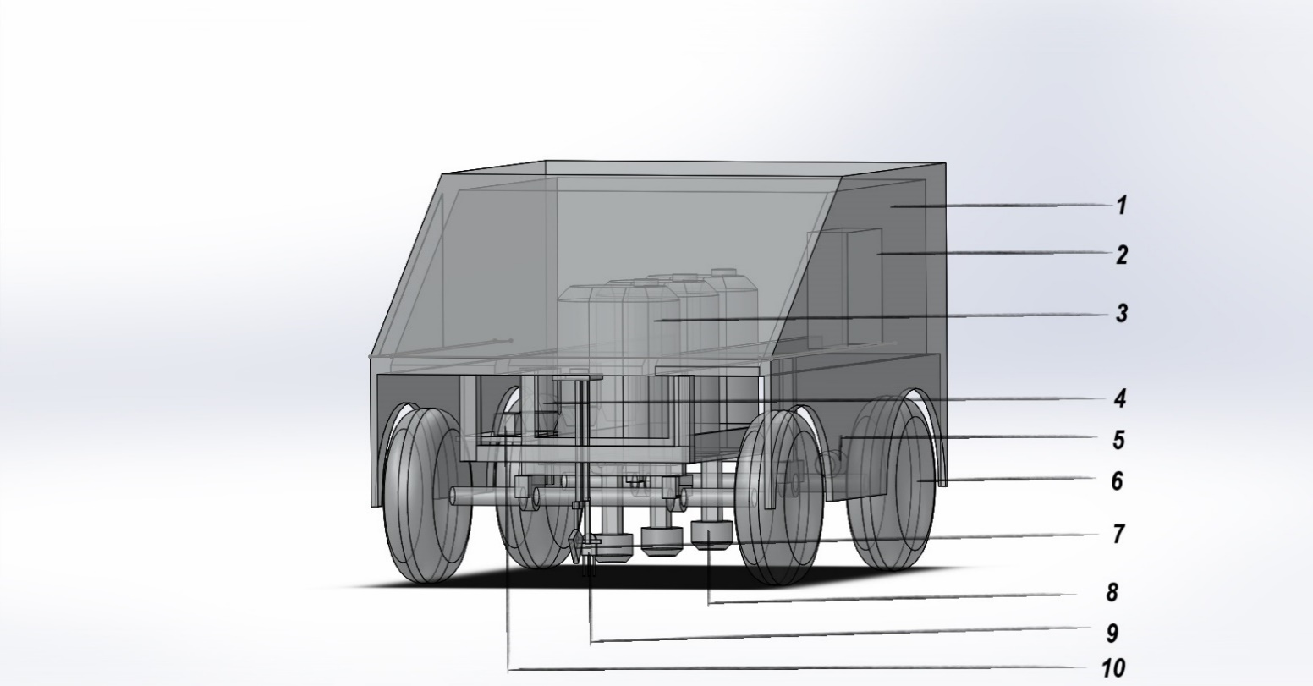

10.12V Lead acid battery

9.NPK Sensor

8.5 Hole Nozzle

7.Digger

6.12 Inch Wheels

5.12V Wiper Motor

4.Diaphragm Pump

3.35 L Tank

2.Circuit Box

1.Steel Frame

**FIG.4.1: CONCEPTUAL DESIGN OF AGRICULTURE SOIL TESTING AND NUTRIENT SPRAYING MACHINE.**

**4.2 MACHINE COMPONENTS**

The agriculture soil testing and nutrient spraying machine has the following components.

● Steel frame

● 35L Tank

● 12V Diaphragm Pump

● Pipes

● Wiper motor

● Sprayer

● 12V Batteries

● ESP32 WROOM micro controller

● NPK sensor

● Power Window Motor

● IC Converter

* Digger

**4.2.1 STEEL FRAME**

A steel frame is a structural component commonly used in various machines and equipment to provide support, stability, and strength. Steel is a preferred material for frames in many applications due to its high strength, durability, and resistance to deformation. The steel frame is the important framework of the machine as it holds all the other components of the machine. The other components such as tank, motor, pump, pipes, wheels etc., are attached to the steel frame. The steel frame is made up of aluminium metal, specifically an aluminium frame, offers many advantages, including its lightweight nature, corrosion resistance, and versatility in various application

**Specifications:**

**TABLE 4.1 SPECIFICATIONS OF STEEL FRAME**

|  |  |
| --- | --- |
| Outer sheet | 0.8 mm |
| Inner pipe material | 1.2 mm |

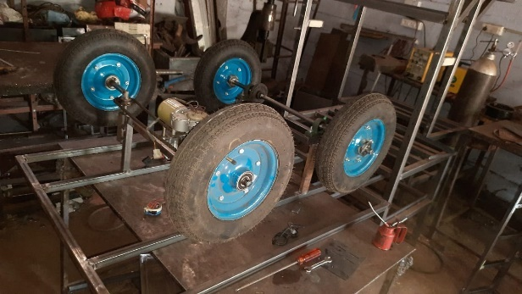

**FIG. 4.2 STEEL FRAME**

**4.2.2 35 L TANK**

The tanks are fitted on the steel frame. Three tanks are fitted one next to the other. Each tank is of 35L capacity. Individual tanks are placed for nitrogen, phosphorus, and potassium. Tank is made up of plastic material. The tank is made of high-density polyethylene (HDPE) or other suitable plastic materials. HDPE is commonly used due to its resistance to corrosion, durability, and compatibility with various chemical solutions, including fertilizers and nutrients.

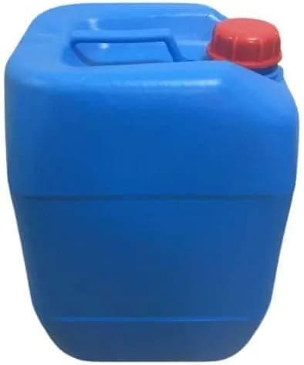

**FIG 4.3 PLASTIC TANK**

**Source:**<https://www.packagingdrums.com/>

**4.2.3 DIAPHRAGM PUMP**

A diaphragm pump is a type of positive displacement pump used to move fluids by means of a flexible diaphragm, which expands and contracts to create pressure variations that draw in and expel the fluid. These pumps are widely used in various industries for their ability to handle a wide range of fluids and their reliable and efficient operation. The Diahragm pump or the motor which is connected to tank is used to suck nutrients from the tank. These pumps are fitted individually for each tank. These pumps are used to flow the fertilizer from the tank. This pump is to suck nutrients from the tank and makes it flow through the sprayer.

**Specifications:**

**TABLE 4.2 SPECIFICATIONS OF DIAPHRAGM PUMP**

|  |  |
| --- | --- |
| Pump capacity | 4.5 lit/min |

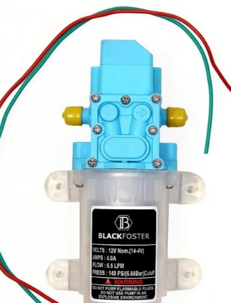

**FIG. 4.4 DIAPHRAGM PUMP**

**Source**:<https://www.mathaelectronics.com/product/dc-12v-60w-high-pressure-water-pump-automatic-switch-5l-min-pump/>

**4.2.4 PIPES**

A pipe is a tubular, hollow, or cylindrical conduit or channel that is used to transport fluids, gases, or granular materials from one location to another. Pipes come in various materials, shapes, and sizes, and they serve a wide range of purposes in various industries and applications. PVC (polyvinyl chloride), CPVC (chlorinated polyvinyl chloride), PE (polyethylene), and PEX (cross-linked polyethylene) are commonly used plastic materials for pipes. They are lightweight, corrosion-resistant, and often used in plumbing and irrigation.

**Specifications:**

**TABLE 4.3 SPECIFICATIONS OF PIPES**

|  |  |
| --- | --- |
| Material | Polyurethane |

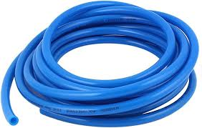

**FIG. 4.5 PIPES**

**Source**:<https://m.indiamart.com/proddetail/10mm-x-6-5mm-pneumatic-air-compressor-pu-hose-pipe-24747960730.html>

**4.2.5 WIPER MOTOR**

A wiper motor is a key component in automotive and other applications where it is used to control the motion of windshield wipers. Its primary purpose is to move the wiper arms back and forth across the windshield to remove rain, snow, or debris. The wiper motor is used for the rotational movement and turning of the wheels. When electrical power is supplied to the motor, it starts to rotate. The motor’s rotational motion is converted into reciprocating (back and forth) motion by the linkage mechanism. It is also used for all the rotational movements. It is used to rotate rods and wheels. The wiper motor is attached to the worm gear, which transmits the force to do the rotational motion.

**Specifications:**

**TABLE 4.4 SPECIFICATIONS OF WIPER MOTOR**

|  |  |
| --- | --- |
| Motor | 60 rpm |
| Voltage | 12V |
| Torque | 50 kg/cm |

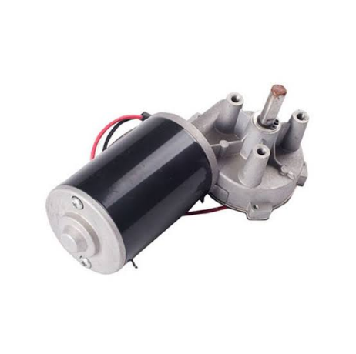

**FIG. 4.6 WIPER MOTOR**

Source:<https://www.ubuy.co.in/product/1EUFXHZ6-showsen-new-front-windshield-wiper-motor-fit-97-02-tj-wrangler>

**4.2.6 SPRAYER**

The "5 Holes Speaker Nozzle" is a component used in certain sprayers. It combines sprayer technology with a nozzle that has five holes for dispersing liquid. The "speaker" description may indicate a design ensuring even liquid distribution like speakers disperse sound. This nozzle could benefit gardening, agriculture or cleaning needing precise, uniform liquid dispersion. The battery power offers convenience and portability operating without a continuous power source. In summary, the "Battery Sprayer 5 Holes Speaker Nozzle" innovates sprayer design for efficiency and user experience in various spraying tasks.

**Specifications:**

**TABLE 4.5 SPECIFICATIONS OF SPRAYER**

|  |  |
| --- | --- |
| Type of sprayer | Pump sprayer |
| Material composition | Durable plastic |
| Pressure | 30 psi |

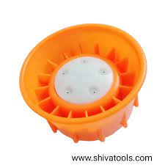

**FIG. 4.7 FIVE HOLE SPEAKER NOZZLE**

**Source**:<https://shivatools.com/products/battery-sprayer-5-holes-speaker-nozzle>

**4.2.7 12V BATTERIES**

A 12V battеry is a typе of rеchargеablе battеry that providеs еlеctrical powеr at a voltagе of approximatеly 12 volts. Thеsе battеriеs arе commonly usеd in a widе rangе of applications, from automotivе usе to powеring various dеvicеs and systеms.The batteries are provided to supply power to the motor and other sources for the operation of the machine components. As the power of the battery decreases, the speed and efficiency of the machine also decreases. This battery can be added upto 24V and more efficiency can be obtained.

**Specifications:**

**TABLE 4.4 SPECIFICATIONS OF 12V BATTERIES**

|  |  |
| --- | --- |
| Battery Type | Lead-Acid Battery |
| Capacity | 12AH |

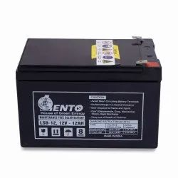

**FIG. 4.8 BATTERIES**

**Source:**<https://m.indiamart.com/proddetail/12ah-12v-smf-vrla-battery-23200489491.html?pos=2&pla=n>

**4.2.8 12V POWER RELAY**

A power relay is an electrical component used to control the flow of electrical power within an electrical circuit. It is an electromagnetic switch that can handle high currents or voltages, making it an essential part of various electrical and electronic systems. The power relay is used to control the high voltage, high current load in motor, solenoid valves and AC loads. It interfaces with ESP32-WROOM microcontroller, IoT and microcontroller. Each movement of the machine such as forward, backward, turning etc., are operated by the relay module using the IoT components.

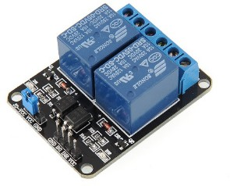

**FIG. 4.9 POWER RELAY**

**Source**:<https://probots.co.in/12v-30a-250v-1-channel-relay-module-with-optocoupler-isolation-board-for-arduino.html>

**4.2.9 ESP32-WROOM CONTROLLER**

The ESP32-WROOM is a versatile Wi-Fi module developed by Espressif Systems, featuring a dual-core processor for efficient multitasking, integrated support for 802.11 b/g/n Wi-Fi and Bluetooth 4.2/BLE connectivity, and an integrated antenna. Its GPIO pins, low power consumption, and compatibility with development platforms like Arduino IDE and ESP-IDF make it ideal for a wide range of IoT and embedded systems projects. The module supports interfaces such as SPI, I2C, UART, PWM, and ADC, providing flexibility for connecting various sensors and peripherals. Security features like secure boot and flash encryption enhance its reliability, and it allows for Over-The-Air (OTA) updates for remote firmware updates. With widespread use in IoT applications, the ESP32-WROOM module is known for its programmability, energy efficiency, and ease of integration into diverse projects.

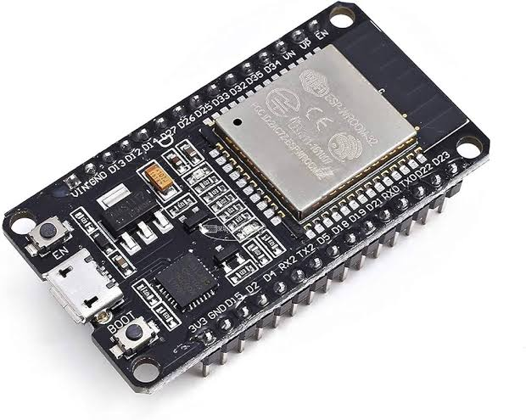

**FIG. 4.10 ESP32 WROOM MODULE**

**Source**:<https://amzn.eu/d/8qmEwSx>

**4.2.10 NPK SENSOR**

An NPK sensor is a specialized sensor used in agriculture and horticulture to measure the concentration of essential nutrients in the soil, specifically nitrogen (N), phosphorus (P), and potassium (K). These macronutrients are vital for plant growth, and their levels in the soil can significantly impact crop health and productivity. NPK sensors provide real-time data on nutrient levels, helping farmers and growers make informed decisions regarding fertilization and nutrient management. The NPK sensor is used to determine the amount of nutrients such as nitrogen, phosphorus, and potassium in the soil when the probe is dipped in the soil. These nutrients are the major nutrients that should be present in the soil for better growth of the plants. The NPK sensor senses the nutrients which is connected to the IoT module and then connected to the mobile application to view the nutrient content.

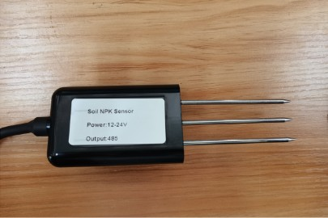

**FIG. 4.11 NPK SENSOR**

**Source:**<https://odlstore.com/dragino/910-lsnpk01-lorawan-soil-npk-sensor-for-iot-of-agriculturebase-on-the-lsn50-v2.html>

**4.2.11 POWER WINDOW MOTOR**

The power window motor was originally designed for automotive power windows. However, in recent years robotics engineers and builders have increasingly utilized this motor type in robot designs, especially for combat robots given its performance capabilities and competitive pricing. The default motor configuration may not be ideally suited for external attachment of parts. We recommend considering models of the power window motor that include a coupling mechanism to facilitate integration. Additionally, take note that the motor housing is asymmetric, with options for left or right-sided output shafts. Be certain to select the appropriate variant to suit your design prior to purchase.

**Specifications:**

**TABLE 4.5 SPECIFICATIONS OF POWER WINDOW MOTOR**

|  |  |
| --- | --- |
| Speed(rpm) | 30 |
| Torque(kg/cm) | 25 |

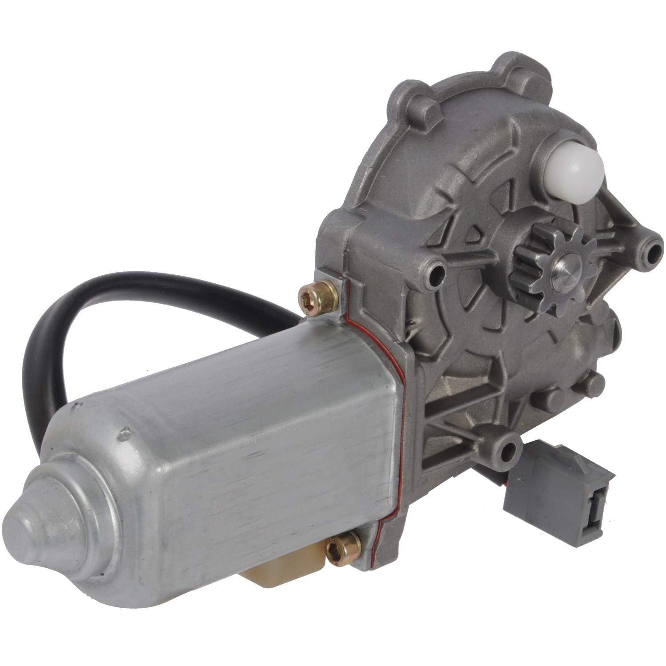

**FIG. 4.13 POWER WINDOW MOTOR**

**Source**:<https://www.amazon.com/Cardone-Select-82-377-Window-Motor/dp/B000CFFAJO>

**4.2.12 IC CONVERTER**

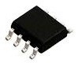 The IC converter is used to convert the RS485 module to RS232. This is done so because the sensor communication is RS485 but the IOT module communication is RS232. So, to convert the communication signals of the sensor this IC converter is used. The sensor is connected in the IC converter and the values of the nutrients in the soil are sensed.

**FIG. 4.14 IC CONVERTER**

Source:<https://components101.com/ics/ncp3064-dc-dc-converter-ic>

**4.2.13 DIGGER**

A digger, also known as an excavator, is a heavy construction machine used for digging, moving, and lifting large quantities of materials, such as soil, rocks, debris, and other materials at construction sites, mines, and other earthmoving operations. Excavators are versatile pieces of equipment that come in various sizes and configurations to meet specific construction and excavation needs. It is a common practice in various industries and applications. Diggers such as excavators, are heavy machinery designed to dig, scoop, and move earth efficiently, When it comes to placing sensors in the ground.

**4.3 EXPERIMENTAL DESIGN**

Experimental setup is the section where the experiment is described and summarized.The figure 4.12 show below is the Experimental setup of automatic fertilizer mixing machine using PLC.

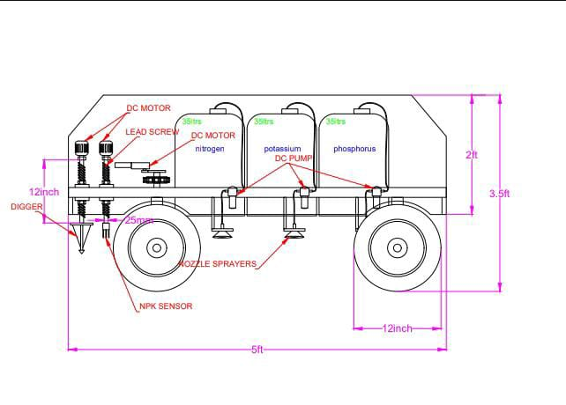

**FIG. 4.16 2D DIAGRAM**

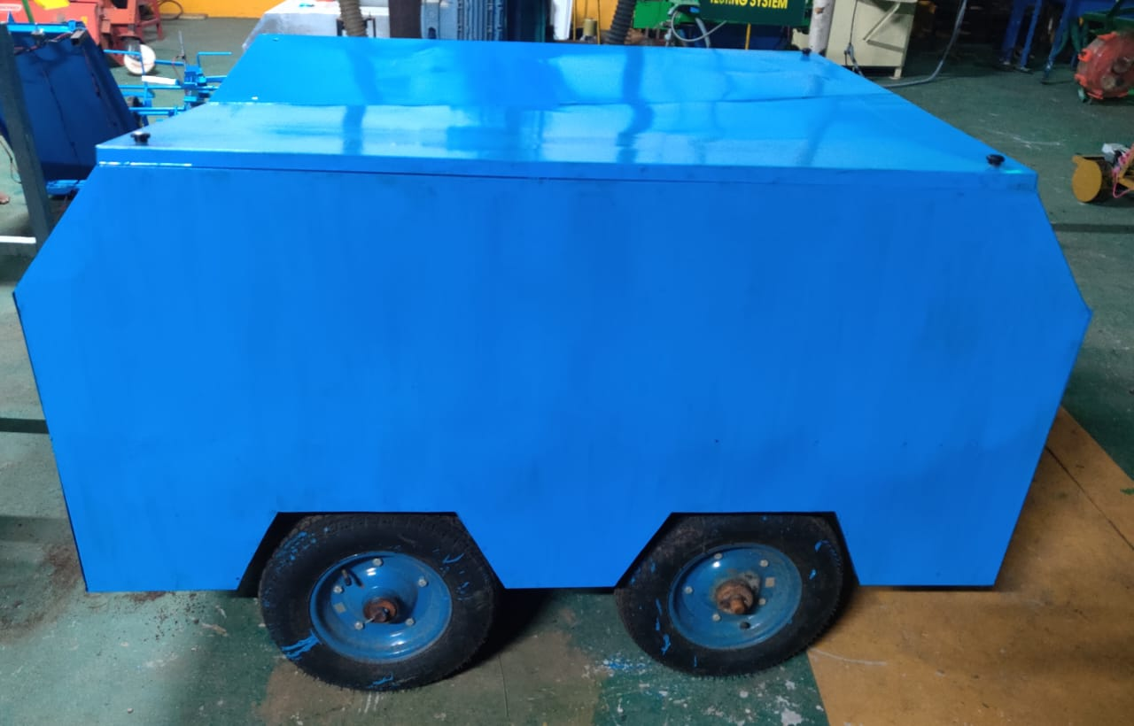

**FIG. 4.17 EXPERIMENTAL SETUP OF AGRICULTURE SOIL TESTING AND**

**NUTRIENT SPRAYING MACHINE**

**4.4 IOT MODULE SETUP**

The IOT module is the basic component board which is programmed by the ESP32-WROOM microcontroller for the machine to work. The processes include movement, the use of a digger to excavate soil for testing, sensor movement, and the display of the NPK values in the soil, which are tested by the sensor, on the mobile application. The mobile application used is Blynk IOT. Therefore, the soil testing is easier for the farmers and the spraying of nutrients can be made easy by this machine. A Wi-Fi module is integrated into the machine's circuit board, enabling the machine and the mobile application to establish a connection via Wi-Fi signals, with a hotspot password for secure access.

The application controls both the movements of the digger and the sensor. The sensor's movements can be adjusted to move forward, backward, right, left, up, and down, all through the application. Similarly, the digger's movements can be controlled to move forward, backward, and up and down through the application.

**4.4.1 ASSEMBLY OF IOT COMPONENTS**

The IOT board consists of IC converter in which the senor of RS485 communication is connected. The IC converter converts the RS485 communication to RS232 communication. The sensor values are read in the IC converter. The IC converter is then connected to the controller which takes the readings from the sensor and processes the values. This controller is connected to the wifi module which gets the RS232 communication values from the controller. The values in the wifi module are viewed in the mobile application. The wifi module is connected to the digger, which controls the digging process, including its rotational and vertical (up and down) movements. Additionally, the wifi module is linked to the controller, which processes commands to operate the relay module. The relay module manages functions such as moving the machine forward, backward, left, right, and controlling the sensor's vertical (up and down) movements. The application controls both the movements of the digger and the sensor. The sensor's movements can be adjusted to move forward, backward, right, left, up, and down, all through the application. Similarly, the digger's movements can be controlled to move forward, backward, and up and down through the application.

Power supply board is connected to all the components. The battery of 12V is connected to the power supply board. The power supply board converts the 12V power supply to 5V as all the IOT components can be supplied by only 5V power. Every relay operation is indicated using LED indicators.

**4.4.2 SCHEMATIC DIAGRAM OF IOT ARRANGEMENTS**

NPK Sensor

RS485 to RS232 IC Convertor

Power Supply

Wi-Fi Module

Controller

Relay for NPK sensor

Relay for digger movement (Upward downward and,rotational)

Relay for machine movement (Front,Back,Right,Left)

Relay for sensor movement (Upward and downward)

**FIG. 4.6 Schematic diagram of IOT components**

**4.5 WORKING PRINCIPLE OF THE MACHINE**

This machine is designed to assess the nutrient content present in the soil and automatically spray any deficient nutrients. In the past, this process was carried out manually by collecting soil samples and sending them to laboratories, which could take up to 15 to 20 days to determine the nutrient levels. However, this machine can instantly detect the NPK (Nitrogen, Phosphorus, and Potassium) content of the soil.

To operate the machine, it is equipped with 12V batteries to power its components. The IOT (Internet of Things) features are activated as the machine is brought into the field. The IOT terminals are connected to the battery, and the machine is switched on. The machine's movement is controlled through a wifi module within the IoT system, which can be managed using a mobile application (in this case, Blynk IOT).

The machine's mobility is achieved through the use of wiper motors to rotate its wheels and control the up and down movement of its sensor. The machine moves to a designated location, where it digs into the soil using a digger. The sensor, integrated into the IOT system, is slowly lowered so that its probes are submerged in the soil. After sensing the soil's nutrient content, the sensor is raised, and the results are displayed in the mobile application.

Upon detecting nutrient deficiencies in the soil, the machine can automatically spray the necessary nutrients. There are separate 35-liter tanks for each nutrient, and these tanks are connected to pumps that draw water from them. The pumps are linked to solenoid valves, which can be controlled by the IOT system. When the sensor identifies that a particular nutrient is below a predetermined threshold, the IOT system sends a signal to the respective solenoid valve, causing it to open and initiating the spraying of the deficient nutrients.

# **CHAPTER 5**

# **OBSERVATION AND ANALYSIS**

**5.1 FIELD TESTING AND OBSERVATION**

The automated soil nutrient assessment and supplementation system utilizes IOT technology to allow real-time monitoring and remote control via a mobile app. Farmers can access data and manage operations conveniently from the app. Using sensors to detect specific nutrient deficiencies, the system tailors supplementation strategies accordingly. This data-driven approach supports sustainable farming practices.

Integrated sensors and actuators give the system autonomous functionality, enhancing practicality by allowing it to sample soil and apply nutrients without constant human intervention. Precisely targeting deficiencies minimizes fertilization waste and environmental impact.Separate nutrient tanks and pumps enhance resource management by enabling farmers to tailor nutrient applications to specific crop needs and conditions. By connecting sensors, IOT, the mobile app, controllers, and automated devices, the system takes a holistic approach to soil management. It provides insights into soil health and nutrients to support informed decisions and sustainability.

Overall, the system represents a shift to more efficient, data-driven agriculture. It empowers farmers to optimize yields while reducing environmental footprint, with potential to revolutionize and sustain soil practices long-term.

**5.2 OBSERVATION AND ANALYSIS**

We conducted soil testing on our experimental plot. As advised by TNAU, we aimed to collect samples from 10-12 points per hectare of land. The plot we selected measured 54 feet in length by 36 feet in width, totaling 1,944 square feet or approximately 0.44 cents.

To test our machine, we fixed 5 sample points within the plot to analyze macronutrient content. At each point, we dug down approximately 6-8 centimeters using a small digging tool. We then inserted our NPK sensor into the dug soil to obtain readings from that location.

More testing will be required across varying conditions to thoroughly evaluate machine performance. Additional notes on results will be recorded after data analysis is complete.

mg/kg - represents 1 milli gram of nutrient in the 1 killo gram of soil.

|  |  |  |  |
| --- | --- | --- | --- |
| **No of Sample** | **Nitrogen (N)(mg/kg)** | **Phosphorus(P)(mg/kg)** | **Potassium(K)**  **(mg/kg)** |
| Sample 1 | 17 | 52 | 75 |
| Sample 2 | 27 | 84 | 77 |
| Sample 3 | 14 | 83 | 75 |
| Sample 4 | 29 | 88 | 83 |
| Sample 5 | 18 | 93 | 85 |
| Average | 21 | 80 | 79 |

**Field Calculation:**

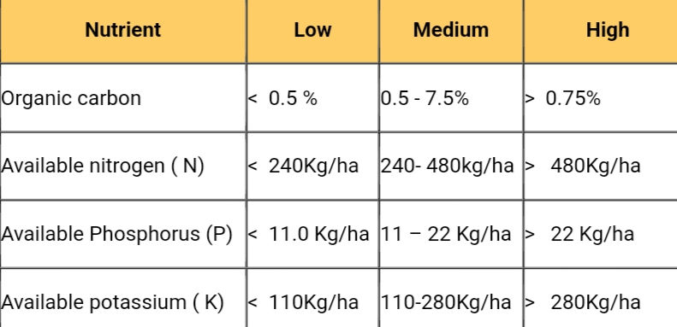

**Source: https: //tnau.ac.in/**

1.Nitrogen(N)

Average(N) = 21 mg/kg

1 ha = 10000 m2

Depth = 8cm = 0.08m

Volume of soil,V = 10000m2 x 0.08m

V = 800 m3

Bulk density for Sandy loamy soil = 1.2 g/cm3 = 1200 kg/m3

m(mass of soil) = 800m3 x 1200 kg/m3 = 960000 kg

N content in soil = 21 mg/kg

Total N content in kg/ha = 960000 kg x 21 mg/kg

= 20160000 mg

= 20160000/100000

= 201.6 kg / ha.

At less than 201.6 kg/ha, the Nitrogen content of the soil appears to be low.

2.Phosphorus(P)

Average = 80 mg/kg

Mass of soil area = 1ha = 10000 m2

Depth = 8cm = 0.08m

Volume of soil = 10000m2 x 0.08m = 800 m3

Bulk density for Sandy loamy soil = 1.2 g/cm3 = 1200 kg/m3

m(mass of soil) = 800m3 x 1200 kg/m3 = 960000 kg

P content in soil = 80 mg/kg

Total P content in kg/ha = 960000 kg x 80 mg/kg

= 76800000 mg

= 76800000/100000

= 768 kg / ha.

At less than 768 kg/ha, the Phosphorus content of the soil appears to be high.

3.Potassium(K)

Average = 79 mg/kg

Mass of soil area = 1ha = 10000 m2

Depth = 8cm = 0.08m

Volume of soil = 10000m2 x 0.08m = 800 m3

Bulk Density for Sandy loamy soil = 1.2 g/cm3 = 1200 kg/m3

m(mass of soil) = 800m3 x 1200 kg/m3 = 960000 kg

K content in soil = 79 mg/kg

Total K content in kg/ha = 960000 kg x 79 mg/kg

= 75840000 mg

= 75840000/100000

= 758.4 kg / ha.

At less than 758.4 kg/ha, the Potassium content of the soil appears to be high.

The values obtained from the device and TNAU were in **close proximity to one another.** Based on both reports, it can be concluded that nitrogen levels were low, phosphorus levels were high, and potassium levels were high.

Acquired data from the device:

|  |  |  |
| --- | --- | --- |
| **Nitrogen**  **(kg/ha)** | **Phosphorus**  **(kg/ha)** | **Potassium**  **(kg/ha)** |
| 201.6(Low) | 768(High) | 758.4(High) |

Soil test result data obtained from TNAU.

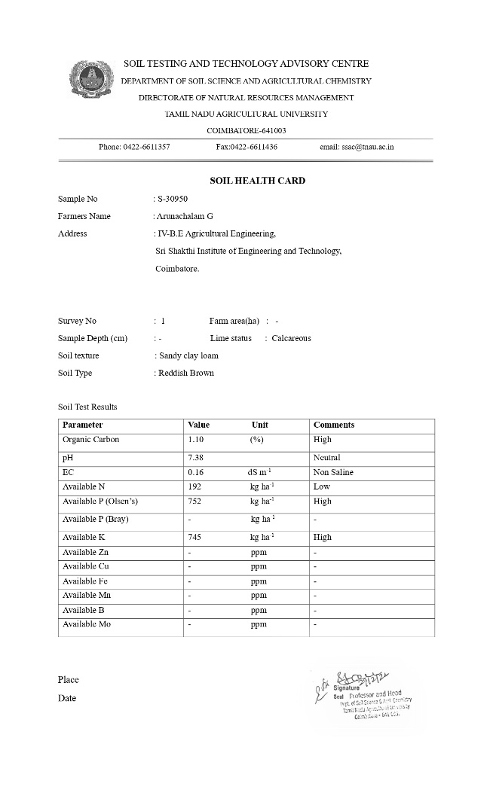

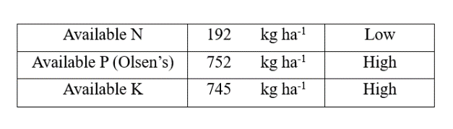

**Time Management**

Our technology has advanced beyond all traditional approaches. Resource allocation is exclusively dedicated to this initiative. As we understand the requirements, some sample points must be analyzed at specific depths. We have already determined the time needed to excavate soil to a depth of 6-8 cm and insert NPK sensors, which typically takes 5-6 minutes per data collection operation. As recommended, approximately 15-20 sampling locations should be examined per hectare to sufficiently map soil nutrients.

**Time Calculation:**

Time estimation for soil sampling of a one acre plot

**one acre plot** equals **43560** square feet in area.

Sample collection will involve taking measurements at **20 individual sample points** across the acre.

Based on prior experience, it takes approximately to complete the sampling process at each point.

The total estimated time to collect samples from all 20 points on the one acre plot = 20 x 6 mins

Estimated time = 120 mins

**5.3 COST ANALYSIS**

The total cost of the project is estimated as Rs.51200/- which include all the cost for the components, fabrication, and programming.

**TABLE 5.3 MATERIAL COST**

|  |  |  |
| --- | --- | --- |
| **COMPONENT** | **QUANTITY** | **COST** |
| DC MOTOR FOR WHEELS | 4 | 900 X 4 (3600) |
| DC MOTOR FOR DIGGERS & UP/DOWN MOVEMENT | 3 | 900 X 3 (2700) |
| WHEELS | 4 | 1600 X 4 (6400) |
| WATER TANK | 3 | 600 X 3 (1800) |
| PUMP | 3 | 400 X 3 (1200) |
| OVERALL CHASSIS |  | 13000 |
| BATTERY | 2 | 2500 |
| NPK SENSOR | 1 | 7500 |
| EMBEDDED OVERALL WITH ESP32-WROOM CONTROLLER |  | 7500 |
| LABOR COST |  | 5000 |
|  | **TOTAL** | **51200** |

# **CHAPTER 6**

# **RESULT AND DISCUSSION**

**6.1 GENERAL**

The project components and methodology has been discussed in the previous chapters. Therefore, this project has been initiated to solve the issue of testing the soil and spraying the nutrients which has been done manually during early days. IOT is an automated process which makes the user to do all the process automatically without any human intervention. It is provided with transport wheels for the easy movement of the machine.

**6.2 RESULT AND DISCUSSION**

An automated soil assessment and nutrient supplementation system utilizing IOT technology was presented today. The system aims to enhance efficiency, sustainability, and data-driven decision making in agriculture through real-time soil monitoring and mobile control capabilities.

The overall aim of the project is to address challenges with manual soil testing and nutrient application using an automated IOT-based approach. By integrating wheels, motors, sensors and an embedded system, the technology seeks to streamline processes and reduce human intervention. However, a more thorough evaluation of accuracy, efficiency and cost compared to manual methods is still needed for a comprehensive assessment.

Initial soil testing of an experimental plot revealed average macronutrient levels of nitrogen at 21 mg/kg, phosphorus at 80 mg/kg, and potassium at 79 mg/kg. These values were derived from five sample points within a 1,944 square foot area, suggesting potential nutrient variation across the plot and emphasizing the importance of precision in supplementation.

Time savings for soil sampling was also demonstrated, with an estimated reduction from 120 minutes to sample 20 points on one acre compared to traditional methods. Further considerations include accurate sampling depths and varying condition impacts. The 0.95 m/s revolution speed calculation provides operational insight but requiring more discussion on significance to soil sampling and nutrient application performance.

Detailed nitrogen, phosphorus and potassium content analysis revealed valuable insights, such as low nitrogen below 240 kg/ha but relatively high phosphorus and potassium exceeding benchmarks. These findings indicate targeted nutrient adjustment opportunities to optimize soil health.

In conclusion, the presented IOT-driven automated soil assessment and nutrient supplementation system represents significant progress in advancing agricultural practices. Real-time soil monitoring and mobile control addresses limitations of manual testing and nutrient application. Initial tests revealed promising results in terms of nutrient variations and time efficiency. However, a comprehensive evaluation of accuracy, efficiency, and cost-effectiveness compared to conventional methods is imperative for broader adoption. Integrated components including wheels, motors, sensors, and an embedded system show potential to minimize human intervention. Operational insights from revolution speed calculation hint at system performance warranting further discussion. Detailed nutrient analysis identifies targeted adjustment opportunities for optimizing soil health. Ongoing research and comparative studies will be crucial as the system evolves to validate efficacy and ensure integration into diverse agricultural landscapes

# **CHAPTER 7**

# **CONCLUSION**

The use of IOT also allows for data collection and analysis, which can help farmers to make more informed decisions on nutrient requirements and application. By analyzing data on weather conditions, soil moisture, and other environmental factors, farmers can optimize the timing and frequency of nutrient application, leading to more precise and efficient nutrient application.

Overall, the integration of ESP32-WROOM micro controller and IOT in the soil testing and nutrient spraying machine is a significant step towards achieving precision farming practices. By enabling targeted and efficient nutrient application, farmers can maximize crop yields while reducing environmental impacts. The use of IOT also opens up opportunities for further advancements, such as machine learning algorithms and artificial intelligence, which can further enhance the efficiency and effectiveness of the soil testing and nutrient spraying machine.

The farmer needs NPK nutrient to the soil for maximum growth of the crop, this fertilizer applicator deducts the soil nutrients and adds the acquired nutrient to the soil. The variable fertilizer applicator is designed with some suitable specifications. It reduces the time taken for the testresults and the spraying fertilizer. It does not require more time to test the soil. This machine concentrates on the nutrient content of the soil.

Demand for agricultural products has risen throughout time as a result of population growth. To improve output efficiency, new developments in agricultural machinery are being made at every opportunity. As a result, while the advent of technology has eliminated many elements that adversely impact the productivity of agricultural work, it hasn't been able to significantly alter how farms have operated in the past. Automation has greatly increased the production, preparation, and other agricultural activity capabilities of many types of farm machines. This reduces the impact of labour on agriculture as well. The experiment's potential has increased breadth in a futuristic vision with the application of this specific approach. Besides the conventional methods of taking the soil samples and testing it in laboratory for 15 to 20 days, this method is used for easy testing of the nutrients in the soil which gives immediate values of the nutrient in the soil and automatically sprays the deficient nutrient. This method can be done within half a day compared to the early methods of the testing the nutrient content in the soil.

It automatically sprays the nutrients which are less in the soil automatically. It will reduce the time taken for the test results. The variable fertilizer applicator enables the farmer to set the nutrients requirement of a specific place in the field. After reading and reviewing many literature papers, this project is useful for the farmers in many ways

* It does not require more time to test the soil.
* By using this, the nutrient content of the soil is displayed on the screen.
* This project mainly concentrates on the nutrient content of the soil.
* It also sprays the nutrients which are less in the soil.

**REFERENCES**



1. Mountier, N. S., J. L. Griggs, and G. A. C. Oomen. "Sources of error in advisory soil tests: I. Laboratory sources." New Zealand journal of agricultural research 9, no. 2 (1966).
2. Brupbacher, Robert Hartmann. "Analytical methods and procedures used in the soil testing laboratory." (1968).
3. Cate Jr, Robert B., and Larry A. Nelson. "A simple statisticalprocedure for partitioning soil test correlation data into two classes." Soil Science Society of America Journal 35, no. 4 (1971): 658-660.
4. Kenneth H. Solomon, Dennis C. Kincaid, James C. Bezdek."Drop Size Distributions for Irrigation Spray Nozzles "(1985).
5. Osmond, Deanna L., Lin Xu, Noah N. Ranells, Steve C. Hodges, Roger Hansard, and Stephen H. Pratt. "Nitrogen loss estimation worksheet (NLEW): An agricultural nitrogen loading reduction tracking tool." The Scientific World Journal 1 (2001): 777-783
6. Jones Jr, J. Benton. Laboratory guide for conducting soil tests and plant analysis. CRC, 2001
7. J. Lowenberg-DeBoer. “Precision Farming or Convenience Agriculture” (2003)
8. Hofman, Georges, and Oswald Van Cleemput. "Soil and plant nitrogen." (2004).
9. Buchholz, Daryl D., James Richard Brown, J. D. Garret, R. G. Hanson, and H. N. Wheaton. Soil test interpretations and recommendations handbook. Columbia, MO, USA: University of Missouri-College of Agriculture, Division of Plant Sciences, 2004.
10. Maguire, Rory, and Steven E. Heckendorn. "Laboratory procedures: Virginia Tech soil testing laboratory." (2005).
11. Arregui, L. M., and M. Quemada. "Strategies to improve nitrogen use efficiency in winter cereal crops under rainfed conditions." Agronomy Journal 100, no. 2 (2008): 277-284.
12. ArnoldW.Schumann."PreciseP lacement and VariableRate FertilizerApplicationTechnologies forHorticulturalCrops"(2010).
13. Vamanan, Ramesh, and K. Ramar. "Classification of agricultural land soils a data mining approach." International Journal on Computer Science and Engineering, ISSN (2011): 0975-3397.
14. Bah. A, S.K. Balasundram, M.H.A. Husni. “Sensor Technologies for Precision Soil Nutrient Management and Monitoring”. American Journal of Agricultural and Biological Sciences 7 (1): 43-49, 2012
15. Gholap, Jay, Anurag Ingole, Jayesh Gohil, Shailesh Gargade, and Vahida Attar. "Soil data analysis using classification techniques and soil attribute prediction." arXiv preprint arXiv:1206.1557 (2012).
16. Nathan, Manjula V., Jon A. Stecker, and Uichang Sun. "Soil testing in Missouri: A guide for conducting soil tests in Missouri (2012)." (2012).
17. Bradley K. Fritz, W.C Hoffmann, W.E. Bagley,G. R. Kruger,3Zbigniew Czaczyk, & R. S. Henry." Measuring droplet size of agricultural spray nozzles-measurement distance and airspeed effects"(2014).
18. Medar, Ramesh A., and Vijay S. Rajpurohit. "A survey on data mining techniques for crop yield prediction." International Journal of Advance Research in Computer Science and Management Studies 2, no. 9 (2014): 59-64.
19. Bhuyar, Vrushali. "Comparative analysis of classification techniques on soil data to predict fertility rate for Aurangabad District." Int. J. Emerg. Trends Technol. Comput. Sci 3, no. 2 (2014): 200-203.
20. S R Kulkarni , R V Nyamagoud, Hareesh Naik, Mohan Futane. "Fabrication of Portable Foot Operated Agricultural Fertilizers and Pesticides Spraying Pump "(2015).
21. Nitish Das ,Vinayak Khawas,Namit Maske ,Er. R. D. Dhete, Dr. S. K. Chaudhary ."Agricultural Fertilizers and Pesticides Sprayers - A Review"(2015).
22. Ashwini A. Chitragar, Sneha M. Vasi, Sujata Naduvinamani, Akshata J. Katigar and Taradevi I. Hulasogi “Nutrients Detection in the Soil”. International Journal on Emerging Technologies (Special Issue on ICRIET2016) 7(2): 257-260(2016).
23. Vaibhav Ingale, Rashmi Vaidya, Amol Phad, Pratibha Shingare, “A Sensor Device for Measuring Soil Macronutrient Proportion using FPGA”, IEEE, 2016.
24. Amrutha A, Lekha R, A Sreedevi, “Automatic Soil Nutrient Detection and Fertilizer Dispensary System”, IEEE, 2016.
25. Hazelton, Pam, and Brian Murphy. Interpreting soil test results: What do all the numbers mean?. CSIRO publishing, 2016.
26. Pruthviraj Pawar , Aniket Mahajan , Sumeet Pawar,Vineet Pawar, S.S. Pachbore,M.S.Bachhav. "Design & Fabrication of Organic Fertilizer Manufacturing Machine" (2017).
27. Sharma, Lakesh K., and Sukhwinder K. Bali. "A review of methods to improve nitrogen use efficiency in agriculture." Sustainability 10, no. 1 (2017): 51.
28. Sirsat, Manisha Sanjay, Eva Cernadas, M. Fernández-Delgado, and R. Khan. "Classification of agricultural soil parameters in India." Computers and electronics in agriculture 135 (2017): 269-279.
29. Premasudha, B. G., and H. U. Leena. "ICT enabled proposed solutions for soil fertility management in Indian agriculture." In Proceedings of the International Conference on Data Engineering andCommunication Technology: ICDECT 2016, Volume 2, pp. 749-757. Springer Singapore, 2017.
30. Qi, Yue, Yueying Leng, Min Wang, Yinan Hu, and Yane Bai. "Design of decision support system for soil testing and formula fertilization based on the intelligent agriculture." In 2016 4th International Conference on Machinery, Materials and Information Technology Applications, pp. 1095-1100. Atlantis Press, 2017.
31. Mohammed Abu Basim Nazer,Abhishek Hariharan,Nishanth Solomon,U DevaDharshini."Autobot for precision farming"(2017).
32. Palepu, Ramesh Babu, and Rajesh Reddy Muley. "An analysis of agricultural soils by using data mining techniques." Int. J. Eng. Sci. Comput 7, no. 10 (2017).
33. Rahman, Sk Al Zaminur, Kaushik Chandra Mitra, and SM Mohidul Islam. "Soil classification using machine learning methods and crop suggestion based on soil series." In 2018 21st International Conference of Computer and Information Technology (ICCIT), pp. 1-4. IEEE, 2018.
34. Sirsat, Manisha Sanjay, Eva Cernadas, M. Fernández-Delgado, and Senén Barro. "Automatic prediction of village-wise soil fertility for several nutrients in India using a wide range of regression methods." Computers and electronics in agriculture 154 (2018): 120-133.
35. Bodake, Komal, Rutuja Ghate, Himanshi Doshi, Priyanka Jadhav, and Balasaheb Tarle. "Soil based fertilizer recommendation system using Internet of Things." MVP Journal of Engineering Sciences 1, no. 1 (2018): 13-19.
36. Puno, John Carlo V., Rhen Anjerome R. Bedruz, Allysa Kate M. Brillantes, Ryan Rhay P. Vicerra, Argel A. Bandala, and Elmer P. Dadios. "Soil nutrient detection using genetic algorithm." In 2019 IEEE 11th International Conference on Humanoid, Nanotechnology, Information Technology, Communication and Control, Environment, and Management (HNICEM), pp. 1-6. IEEE, 2019.
37. Rishika Anand, Dimple Sethi, Kavita Sharma, Pooja Gambhir. "soil moisture and atmosphere components detection system using IOT and machine learning", Second International Conference on Smart Systems and Inventive Technology (ICSSIT 2019),IEEE Xplore Part Number: CFP19P17-ART; ISBN:978-1-7281-2119-2.
38. Arun Kumar, Abhishek Kumar, Akash De, Shashank Shekhar, Rohan Kumar Singh.” IoT Based Farming Recommendation System Using Soil Nutrient and Environmental Condition Detection”. International Journal of Innovative Technology and Exploring Engineering (IJITEE) ISSN: 2278-3075, Volume-8 Issue-11, September 2019.
39. Keerthan Kumar, T. G., C. and Shubha, and S. A. Sushma. "Random forest algorithm for soil fertility prediction and grading using machine learning." Int J Innov Technol Explor Eng 9, no. 1 (2019): 1301-1304.
40. Swapna, B., S. Manivannan, and R. Nandhinidevi. "Prediction of soil reaction (Ph) and soil nutrients using multivariate statistics techniques for agricultural crop and soil management." International Journal of Advanced Science and Technology 29, no. 7s (2020): 1900-1912.
41. Domenico Longo ,Giuseppe Manetto, Rita Papa and Emanuele Cerruto." Design and Construction of a Low-Cost Test Bench for Testing Agricultural Spray Nozzles"(2020).
42. Şenol, Hüseyin, Pelin Alaboz, Sinan Demir, and Orhan Dengiz. "Computational intelligence applied to soil quality index using GIS and geostatistical approaches in semiarid ecosystem." Arabian Journal of Geosciences 13 (2020): 1-20.
43. Yadav, Jagdeep, Shalu Chopra, and M. Vijayalakshmi. "Soil analysis and crop fertility prediction using machine learning." Machine Learning 8, no. 03 (2021).
44. Pallevada, Hema, Siva parvathi Potu, Teja Venkata Kumar Munnangi, Bharath Chandhra Rayapudi, Sai Raghava Gadde, and Mukesh Chinta. "Real-time Soil Nutrient detection and Analysis." In 2021 International Conference on Advance Computing and Innovative Technologies in Engineering (ICACITE), pp. 1035-1038. IEEE, 2021.
45. Kartik Avhad, Dhaval Mahajan, Ishan Kharat, Sumit Jadhav. "Soil Nutrients Analysis Techniques and Crop/ Fertilizers Prediction-A Review"(2022).
46. Khalil Misbah , Ahmed Laamrani , Keltoum Khechba , Driss Dhiba and AbdelghaniChehbouni."Multi-Sensors Remote Sensing Applications for Assessing,Monitoring, and Mapping NPK Content in Soil and Crops in African Agricultural Land"(2022).
47. Saurabh S. Kadam, Shubham R. Kulkarni, Shubham S. Salunkhe, Mayur M. Salunkhe."Fabrication of Automatic Agricultural Fertilizers Spraying Machine"(2022).
48. M.Haikal Fauzi, Aliff Danial M. Faizal, M. Nasrin M. Sabri, Mohd Najib Janon, Mahmod Abd Hakim Mohamad, Abdullah Wagiman. "Semi-Automatic Fertilizer Sprayer V2023 "(2023).
49. Senapaty, Murali Krishna, Abhishek Ray, and Neelamadhab Padhy. "IoT-Enabled Soil Nutrient Analysis and Crop Recommendation Model for Precision Agriculture." Computers 12, no. 3 (2023): 61.
50. Spandana, K., and S. Pabboju. "IoT Enabled Smart Agriculture using Digital Dashboard." Indian Journal of Science and Technology 16, no. 1 (2023): 1-11.